Gulf Atlantic is proud to represent McLanahan Corporation, enabling us to provide you with a complete range of mineral and aggregate processing equipment for washing, classifying, crushing, mixing, feeding, dewatering, scrubbing, and screening products such as limestone, granite, sand, gravel, coal, rock, salt, iron ore, wood chips, clay and more.

The McLanahan product line is recognized world-wide as one of the most reliable and versatile engineering, design, and manufacturing companies in the industry. Holding many patents, from the 1800’s through today, the dedicated employees of McLanahan Corporation continually update and modernize aggregate and mineral processing equipment that is reliable, effective, highly productive, and low maintenance – improving your operation’s efficiency and profits.

McLanahan patented and produced the first log washer, the first rotary breaker, the first single roll crusher, and now, with the recent acquisition of the legendary line of heavy crushing equipment designed and built by Universal Engineering, McLanahan and Gulf Atlantic offers a full complement of material handling equipment for your existing operations and future projects.  And, if you have a frac sand project, Gulf Atlantic and McLanahan offers both stationary and portable Frac Sand Processing Operation Equipment.  Whether you need mineral or aggregate processing equipment, repair parts, or just need input on your next project, contact Gulf Atlantic – your McLanahan dealer – at 800-792-7427.  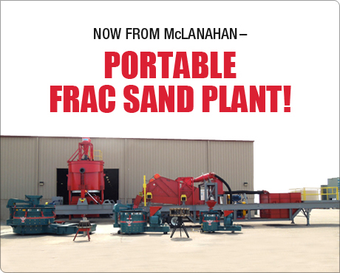  Call 800-792-7427 or 352-628-6674 for Details ! | 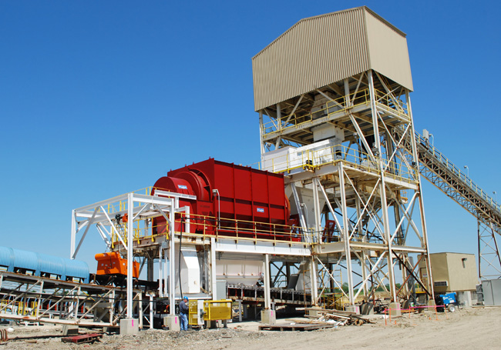  Rotary Breakers are used in the primary and secondary reduction of ROM coal and in the  separation of rock and mine refuse. Currently McLanahan offers two Rotary Breaker  models - the Heavy-Duty Rotary Breaker and the Standard-Duty Rotary Breaker.  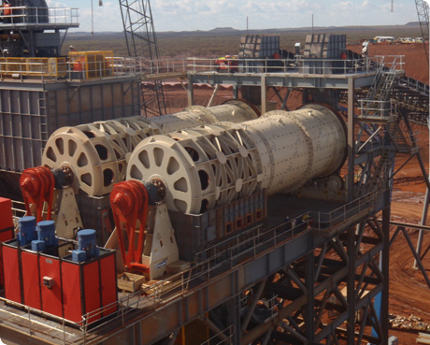  McLanahan Rotary Scrubbers are cost-effective washing units that are an  integral part of a material handling system to upgrade a wide variety of  primary crushed hard rock and ore.  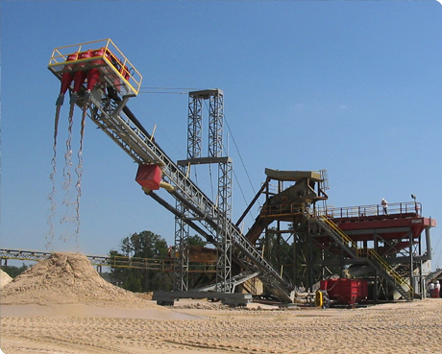  Hydrocyclones, or more simply Cyclones, and derivatives such as the  McLanahan Separator™ are used in many varied applications including  classification, desliming, fines recovery and dewatering.  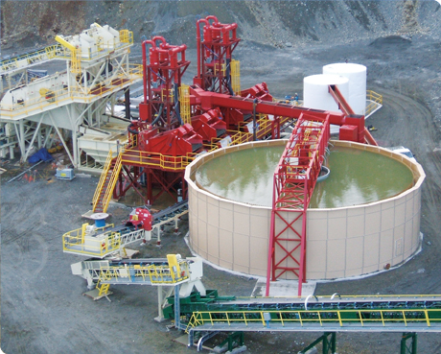  McLanahan’s high-rate Thickeners are simple in design and operation with  specific benefits for today's producers. After having removed usable materials  from the effluent stream, Thickeners recover immediately re-usable process  water adjacent to the plant site.  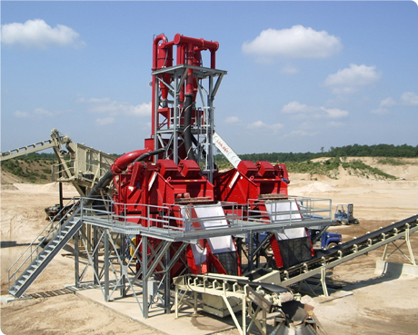  McLanahan Dewatering Screens feature custom-engineered, heavy-duty screen media for the high capacity applications in today’s production driven market. The screen’s robust design features heavy side plates, stress relieved bridges and cross-beams which are Huck-bolted together - not welded - so that individual components can be replaced.  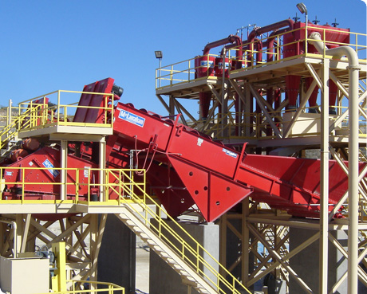  McLanahan Fine Material Screw Washers are primarily used to dewater,  classify and wash minus 3/8” sand or fine minerals. They are designed to  accept feed slurry from Sand Manager Classifying Tanks, Hydrocyclones, Hydrosizers™  and other Fine Material Screw Washers.  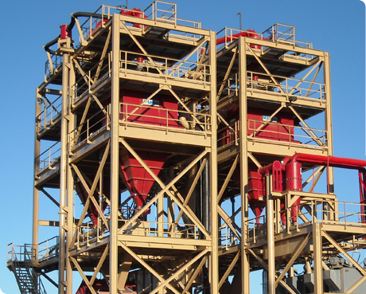  McLanahan Hydrosizers (Density Classifiers) for Frac Sand, construction  and specialty sand, aggregates, iron ore, phosphate, coal, mineral sand  and many other ore concentrates

Process Needed | Equipment Available
Breaking | - Rotary Breakers
Classification | - Sand Manager Classifying Tanks
Contaminant Removal | - Attrition Scrubbers  - Lites Out (Flat Bottom)Classifier  - Coarse Material Screw Washer
Crushing | - DDC-Sizers – Primary, Secondary, Tertiary  - Hammermill Crushers  - Centerfeed Hammermills  - HammerMaster  - LimeMaster  - Minimac Hammermills  - Non-Clog Hammermills  - Standard Hammermill Crushers  - Jaw Crushers  - Primary Impact Crushers  - Andreas Primary Impact Crushers  - MaxCap Primary Impact Crushers  - New Holland Primary Impact Crusher  - VersaCap Primary Impact Crushers  - Roll Crushers – Single, Double, Triple, Quad  - Secondary Impact Crushers  - NGS Secondary Impact Crushers  - Standard Secondary Impact Crushers  - Stage Loader Crusher
Dewatering/Fines Management | - Dewatering Screens  - Recessed Fines Filter Press
Feed Preparation/Scrubbing | - Aggregate Conditioners  - Coarse Material Screw Washers  - Log Washers  - Rotary Scrubbers
Feeders and Feeder-Breakers | - Apron Feeders  - Crawler-Mounted Feeder Breakers  - Drag Feeders  - Reciprocating Plate Feeders  - Reclaim Feeders  - Stationary Feeder-Breakers  - Vibrating Feeders  - Wobbler Feeders
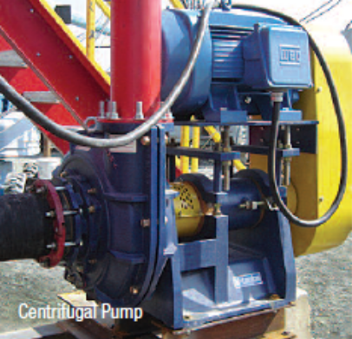  Fines Recovery | - Hydrocyclones and Separators  - Hydrosizer (Density Separator)  - Ultra Fines Recovery Plant
Frac Sand Processing Equipment  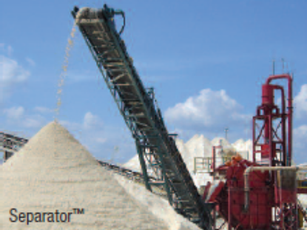 | McLanahan specializes in the design and manufacture of equipment and complete  wet processing systems for producing frac sands used in the oil and gas well drilling  industry.  - Attrition Scrubbers  - Centrifugal Pumps  - Dewatering Screws  - Hydrosizers  - Portable Frac Sand Plants  - Recessed Plate & Membrane Filter Presses  - Thickeners (Clarifiers)  - Complete Plant Design  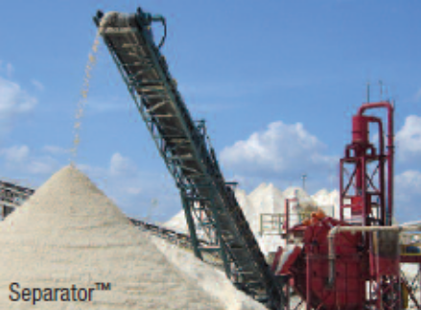
Mixing and Blending | - Pugmill Mixers  - Blendmaster  - Coalmaster  - Pugmaster
Portable Plants | - Portable Frac Sand Plants  - Custom Engineered & Designed Plants  - Open & Closed Circuit Plants Available
Pumps | - Horizontal spindle, centrifugal slurry pumps  - Vertical configuration  - Vortex Flow Impellers  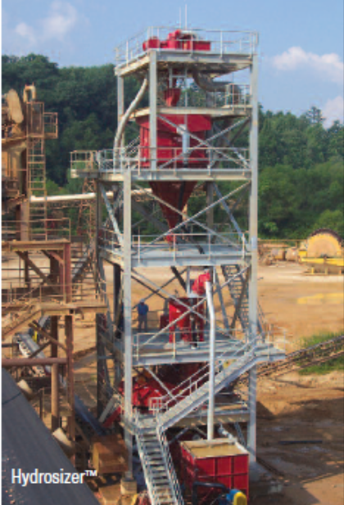
Sampling Systems | - Specifically designed to capture material down  to sand grain in size.
Sand Processing | - Fine Material Screw Washers  - Frac Sand Plant  - Sand Manger Classifying Tanks  - Specialty Sand Plants  - In-Line Blending Sand Plants  - Recipe Sand Plants  - Ultra Sand Plants
Scrubbing and Washing | - Log Washers  - Rotary Scrubbers
Sizing and Screening | - Rotary Trommel Screens  - Screens  - Screenmaster  - Uni-Screen
Water “Fines” Management | - Recessed Plate Filter Press  - Thickeners

For more information or to receive a quotation on McLanahan Equipment, click here

Or Call 800-792-7427 or 352-628-6674


